### Part a - Create ML pipelines in Vertex AI

1. Creating a google project for the assignment

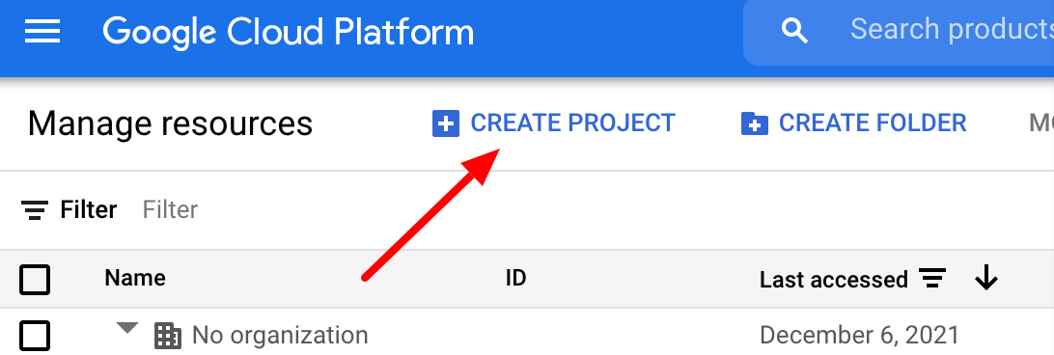

Then from the console activate cloud shell



Authorizing the cloud shell session

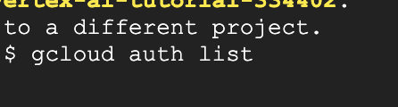

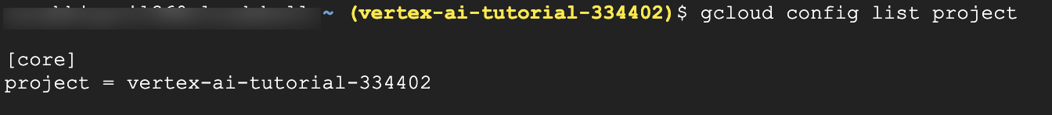



2. Creating a storage bucket to save model assets and data for custom training



4. Creating vertex AI notebook instance

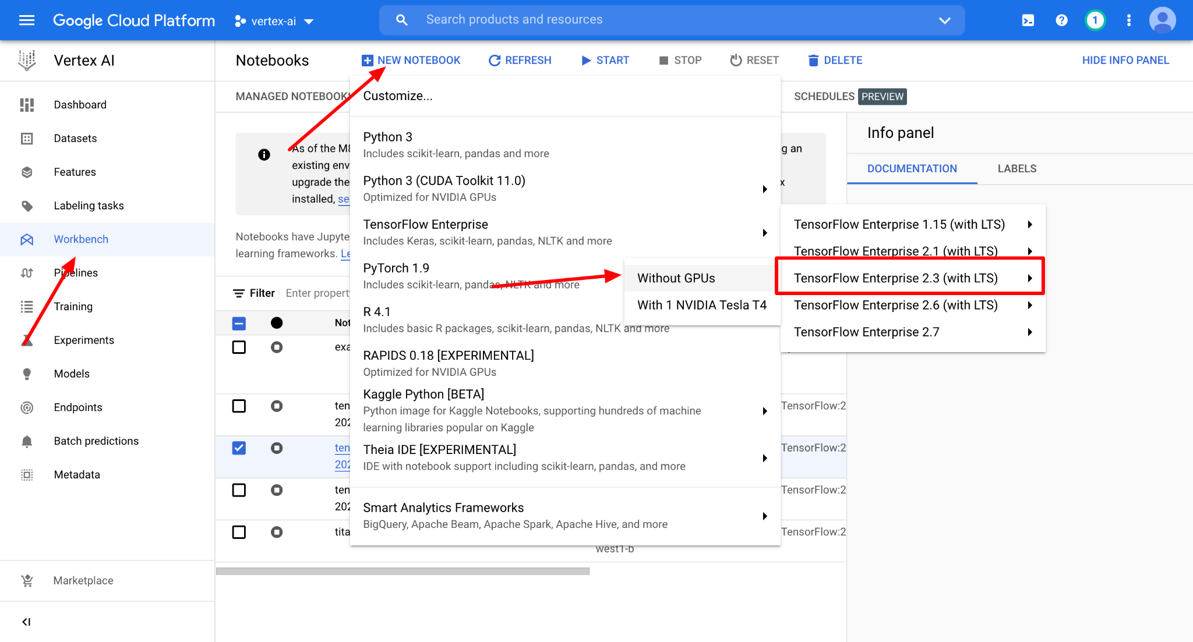

5. Pipeline setup in the vertex AI notebook instance

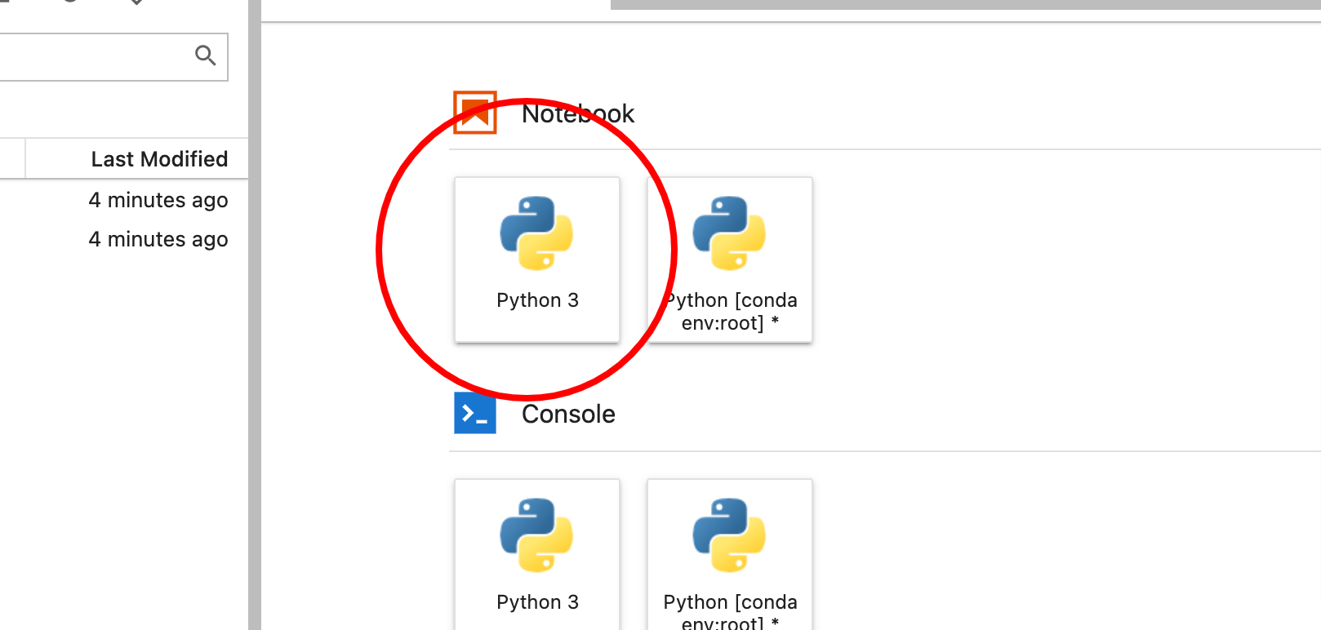

Using Kubeflow pipelines SDK to create the pipeline. Using Vertex AI SDK to run the pipeline in Vertex AI

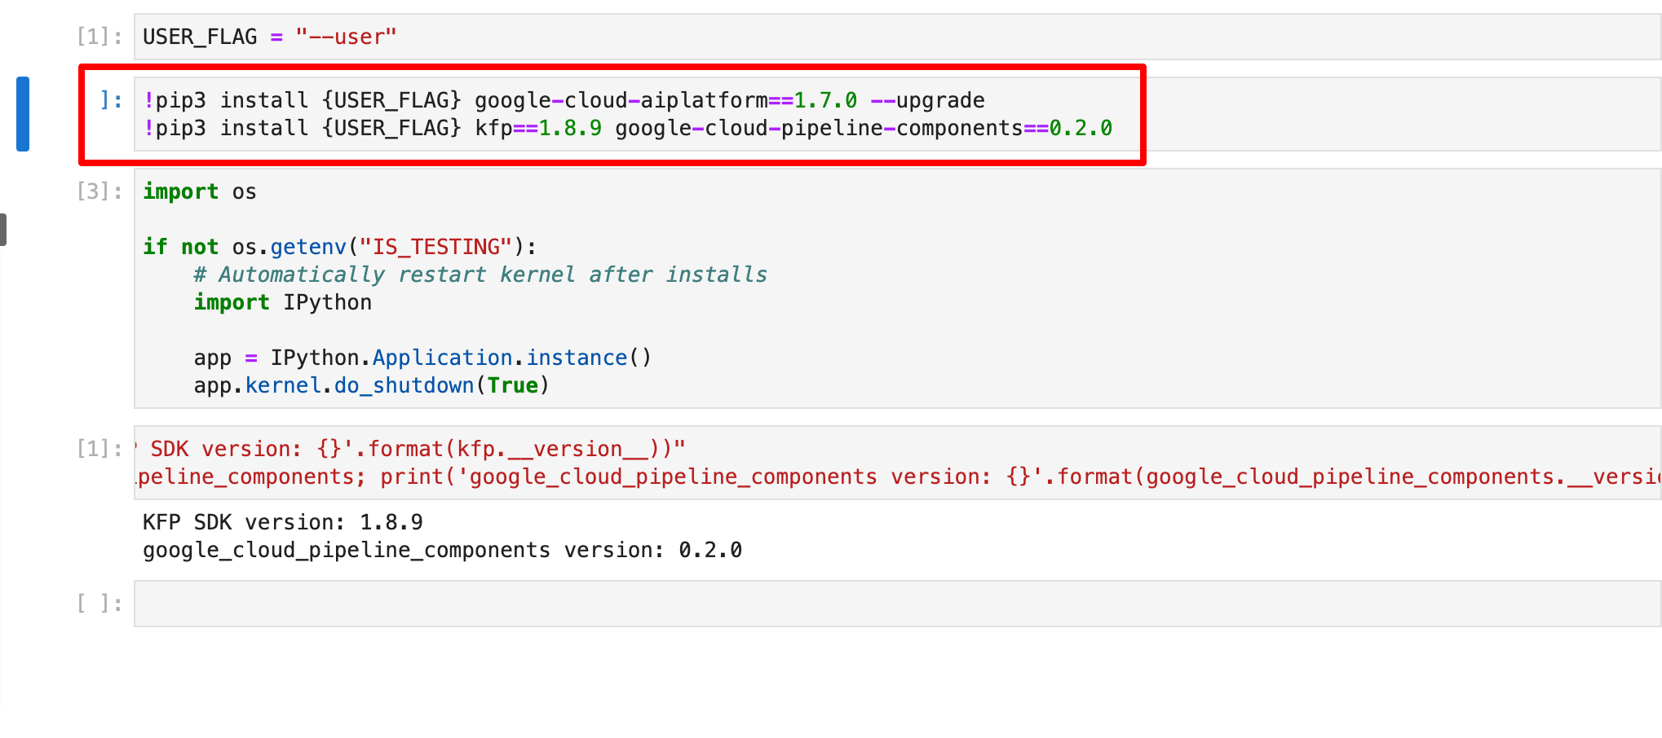

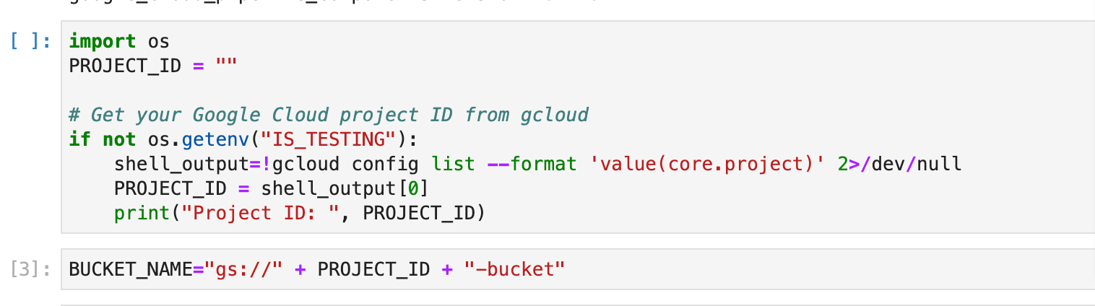

6. Pipeline ready in the vertex UI

* Create a [Dataset](https://cloud.google.com/vertex-ai/docs/datasets/datasets) in Vertex AI
* Train a tabular classification model with [AutoML](https://cloud.google.com/vertex-ai/docs/training/automl-api)
* Get evaluation metrics on this model
* Based on the evaluation metrics, decide whether to deploy the model using conditional logic in Vertex Pipelines
* Deploy the model to an endpoint using [Vertex Prediction](https://cloud.google.com/vertex-ai/docs/predictions/deploy-model-api)



Custom component defined to be used at the end to evaluate and parse them in Vertex UI pipeline can be created using:

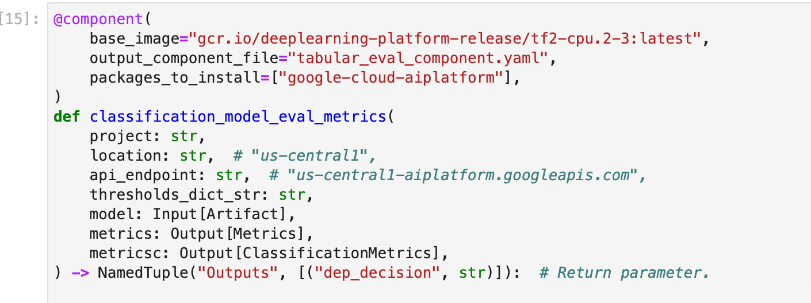

Link to the complete notebook.

Pipeline graph

